For the defining equations,
- You have the variables PS, which is for the y-axis, and DN or V which is for the x-axis.
- The equations of the red lines in the graph as are follows
  - I will give the x and y coordinates for the starting point for the line and the end point for the line
  - The equation of the line will be given in the form of PS for x coordinate and DN or V for y coordinate
- For the axes
  - The axes values are given for the x and y axes
  - the x and y coordinates given for the axes indicate the equations for a line for the gridlines
  - additionally minor gridlines will be given

Graph for vessels-Dangerous gas
Figure 1
Defining Equations (red lines)
PS = 100 000 |  |  |  | PS*V = 100 000
X | Y |  |  | X | Y
0,1 | 100 000 |  |  | 1 | 100 000
1 | 100 000 |  |  | 2 000 | 50
PS = 20 000 |  |  |  | PS*V = 20 000
X | Y |  |  | X | Y
0,1 | 20 000 |  |  | 1 | 20 000
1 | 20 000 |  |  | 400 | 50
V = 1 |  |  |  | PS*V = 5 000
X | Y |  |  | X | Y
1 | 2 000 |  |  | 1 | 5 000
1 | 20 000 |  |  | 100 | 50
PS = 50 |  |  |  | PS*V = 2 000
X | Y |  |  | X | Y
0,1 | 50 |  |  | 1 | 2 000
100 000 | 50 |  |  | 40 | 50

Axis Values
Y- Axis |  |  |  | X- Axis
X | Y |  |  | X | Y
0,1 | 0,1 |  |  | 0,1 | 0,1
0,1 | 1 |  |  | 1 | 0,1
0,1 | 10 |  |  | 10 | 0,1
0,1 | 100 |  |  | 100 | 0,1
0,1 | 1 000 |  |  | 1 000 | 0,1
0,1 | 10 000 |  |  | 10 000 | 0,1
0,1 | 100 000
0,1 | 400 000

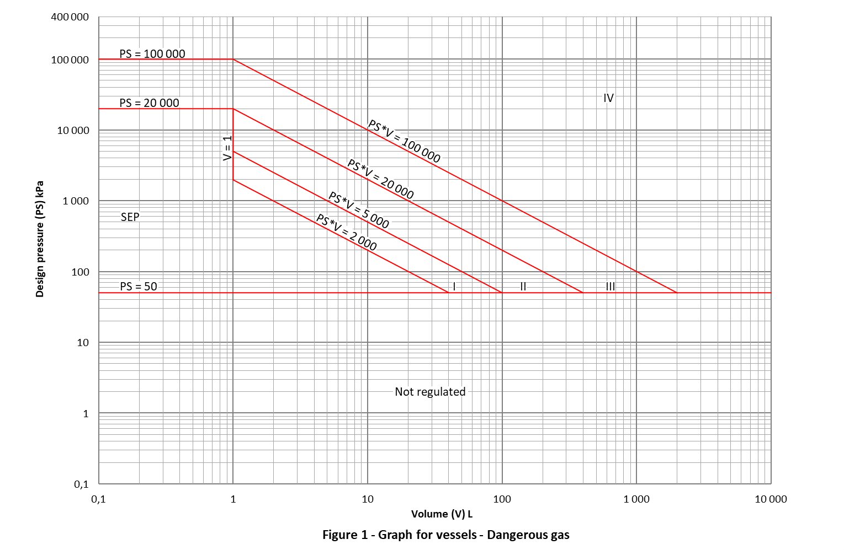

Graph for vessels - Non-dangerous gas
Figure 2
Defining Equations
PS = 300 000 |  |  | PS*V = 300 000
X | Y |  | X | Y
0,1 | 300 000 |  | 1 | 300 000
1 | 300 000 |  | 750 | 400
PS = 100 000 |  |  | PS*V = 100 000
X | Y |  | X | Y
0,1 | 100 000 |  | 1 | 100 000
1 | 100 000 |  | 2 000 | 50
PS = 50 |  |  | PS*V = 20 000
X | Y |  | X | Y
0,1 | 50 |  | 1 | 20 000
10 000 | 50 |  | 400 | 50
PS = 400 |  |  | PS*V = 5 000
X | Y |  | X | Y
750 | 400 |  | 1 | 5 000
10 000 | 400 |  | 100 | 50
V = 1
X | Y
1 | 5 000
1 | 100 000

Axis Values
Y-Axis |  |  | X-Axis
X | Y |  | X | Y
0,1 | 0,1 |  | 0,1 | 0,1
0,1 | 1 |  | 1 | 0,1
0,1 | 10 |  | 10 | 0,1
0,1 | 100 |  | 100 | 0,1
0,1 | 1 000 |  | 1 000 | 0,1
0,1 | 10 000 |  | 10 000 | 0,1
0,1 | 100 000
0,1 | 500 000

Additional Minor gridlines
V = 750
X | Y
50 | 0,1
750 | 500 000

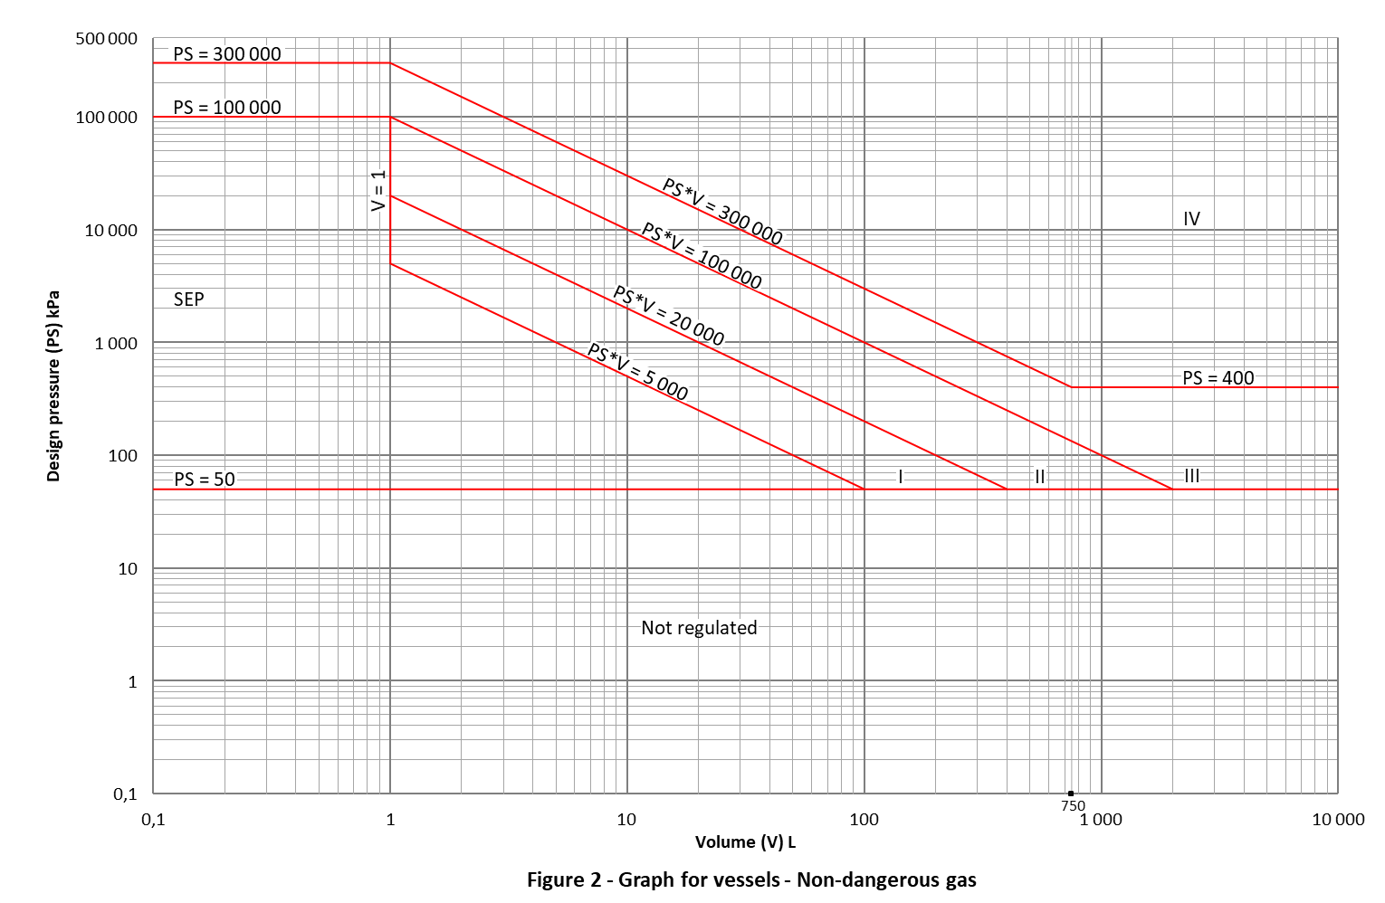

Graph for vessels -Dangerous liquids
Figure 3
Defining Equations
PS = 50 000 |  |  | PS*V = 20 000
X | Y |  | X | Y
0,1 | 50 000 |  | 1 | 20 000
10 000 | 50 000 |  | 400 | 50
PS = 1 000
X | Y
20 | 1 000
10 000 | 1 000
PS = 50
X | Y
0,1 | 50
10 000 | 50
V = 1
X | Y
1 | 500 000
1 | 20 000

Axis Values
Y-Axis |  |  | X-Axis
X | Y |  | X | Y
0,1 | 0,1 |  | 0,1 | 0,1
0,1 | 1 |  | 1 | 0,1
0,1 | 10 |  | 10 | 0,1
0,1 | 100 |  | 100 | 0,1
0,1 | 1 000 |  | 1 000 | 0,1
0,1 | 10 000 |  | 10 000 | 0,1
0,1 | 100 000
0,1 | 500 000

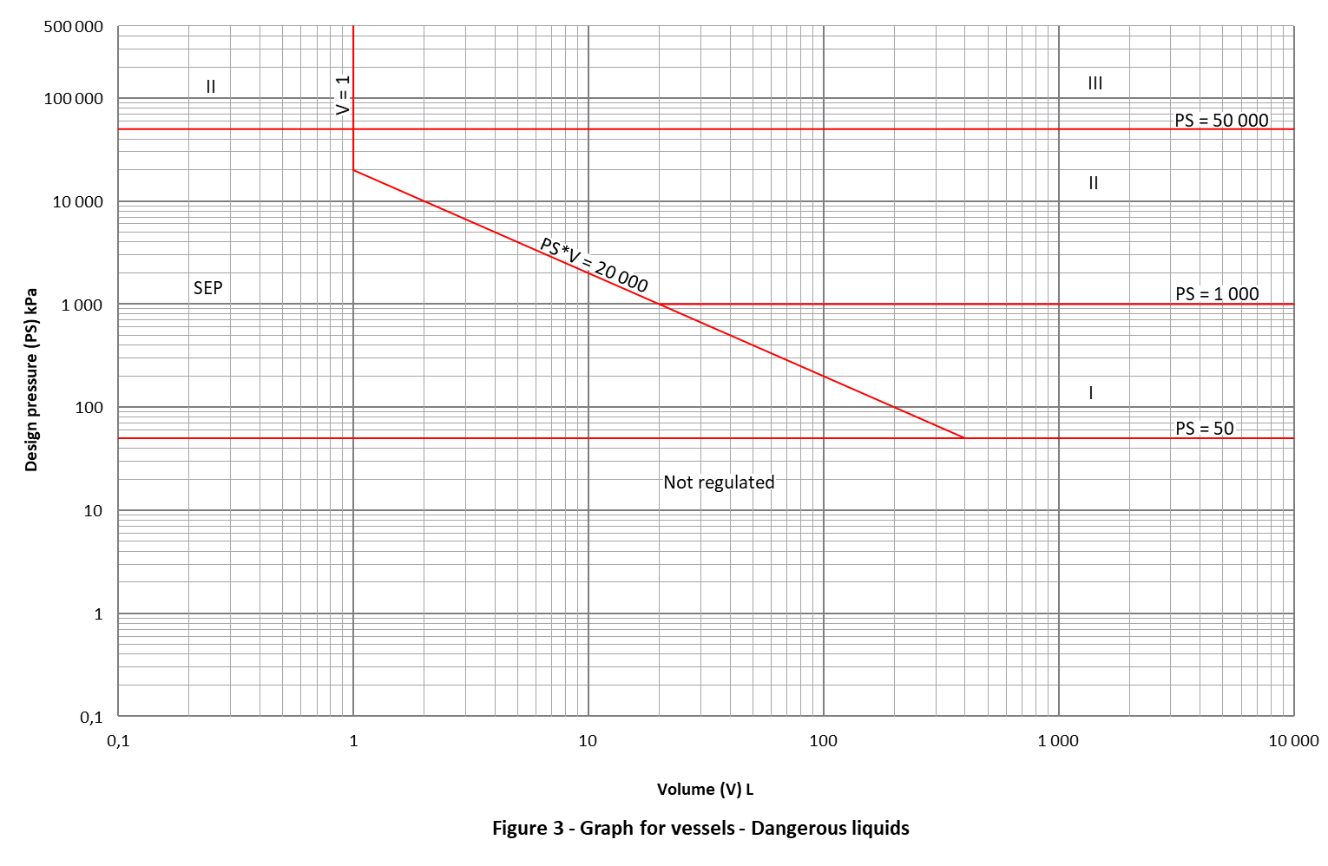

Graph for vessels-Non-dangerous liquids
Figure 4
Defining Equations
PS = 50 |  |  | PS*V = 100 0000
X | Y |  | X | Y
0,1 | 50 |  | 10 | 100 000
100 000 | 50 |  | 1 000 | 1 000
PS = 100 000
X | Y
0,1 | 100 000
10 | 100 000
PS = 1 000
X | Y
1 000 | 1 000
100 000 | 1 000
PS = 50 000
X | Y
20 | 50 000
100 000 | 50 000
V = 10
X | Y
10 | 100 000
10 | 500 000

Axis Values
Y-Axis |  |  | X-Axis
X | Y |  | X | Y
0,1 | 0,1 |  | 0,1 | 0,1
0,1 | 1 |  | 1 | 0,1
0,1 | 10 |  | 10 | 0,1
0,1 | 100 |  | 100 | 0,1
0,1 | 1 000 |  | 1 000 | 0,1
0,1 | 10 000 |  | 10 000 | 0,1
0,1 | 100 000 |  | 100 000 | 0,1
0,1 | 500 000

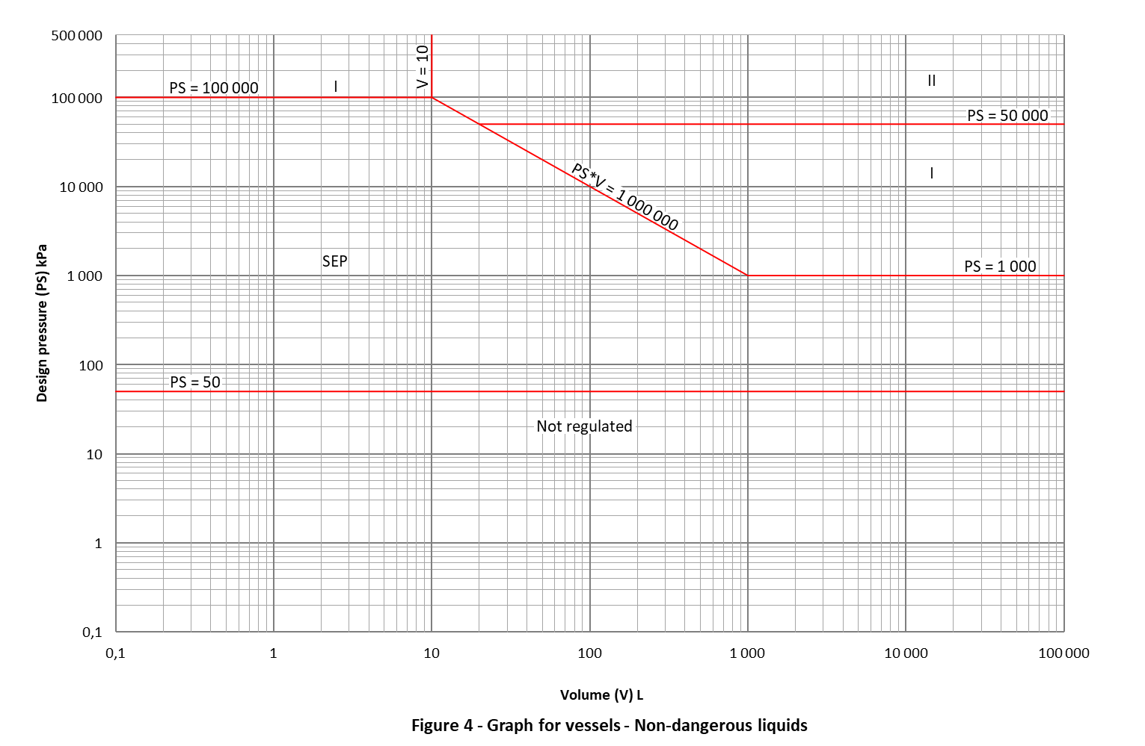
Graph for steam generators
Figure 5
Defining Equations
PS = 50 |  |  | PS*V = 300 000
X | Y |  | X | Y
0,1 | 50 |  | 93,75 | 3 200
10 000 | 50 |  | 1 000 | 300
PS = 3 200 |  |  | PS*V = 20 000
X | Y |  | X | Y
2 | 3 200 |  | 6,25 | 3 200
93,75 | 3 200 |  | 400 | 50
V = 2 |  |  | PS*V = 5 000
X | Y |  | X | Y
2 | 2 500 |  | 2 | 2 500
2 | 100 000 |  | 100 | 50
V = 1 000
X | Y
1 000 | 50
1 000 | 300

Axis Values
Y-Axis |  |  | X-Axis
X | Y |  | X | Y
0,1 | 0,1 |  | 0,1 | 0,1
0,1 | 1 |  | 1 | 0,1
0,1 | 10 |  | 10 | 0,1
0,1 | 100 |  | 100 | 0,1
0,1 | 1 000 |  | 1 000 | 0,1
0,1 | 10 000 |  | 10 000 | 0,1
0,1 | 100 000

Additional Minor gridlines
PS = 3 200(GREY) |  |  | PS = 2500
X | Y |  | X | Y
0,1 | 3 200 |  | 0,1 | 2500
10 000 | 3 200 |  | 10000 | 2500
V = 93.75 |  |  | V= 6.25
X | Y |  | X | Y
93,75 | 0,1 |  | 6,25 | 0,1
93,75 | 100 000 |  | 6,25 | 100 000

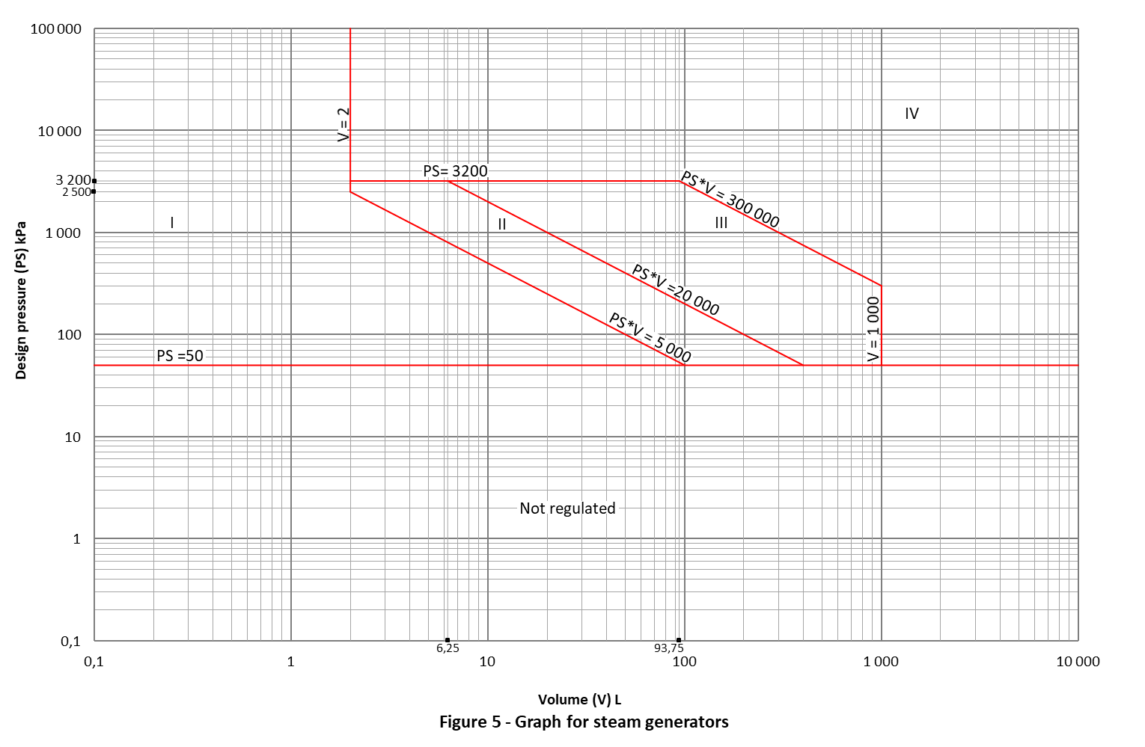
Graph for piping-Dangerous gas
Figure 6
Defining Equations
PS = 50 |  |  | PS*DN = 350 000
X | Y |  | X | Y
1 | 50 |  | 350 | 1 000
2 000 | 50 |  | 100 | 3 500
DN = 25(RED) |  |  | PS*DN = 100 000
X | Y |  | X | Y
25 | 50 |  | 100 | 1 000
25 | 100 000 |  | 25 | 4 000
DN = 100(TOP) |  |  | DN = 350
X | Y |  | X | Y
100 | 3 500 |  | 350 | 50
100 | 100 000 |  | 350 | 1 000
DN = 100(BOTTOM)
X | Y
100 | 50
100 | 1 000

Axis Values
Y-Axis |  |  | X-Axis
X | Y |  | X | Y
1 | 1 |  | 1 | 1
1 | 1 |  | 10 | 1
1 | 10 |  | 25 | 1
1 | 100 |  | 100 | 1
1 | 1 000 |  | 350 | 1
1 | 3 500 |  | 1 000 | 1
1 | 10 000 |  | 2 000 | 1
1 | 100 000

Additional Minor gridlines
PS = 3 500 |  |  | DN = 350(GREY)
X | Y |  | X | Y
1 | 3 500 |  | 350 | 1
2 000 | 3 500 |  | 350 | 50
DN = 25(GREY)
X | Y
25 | 1
25 | 50

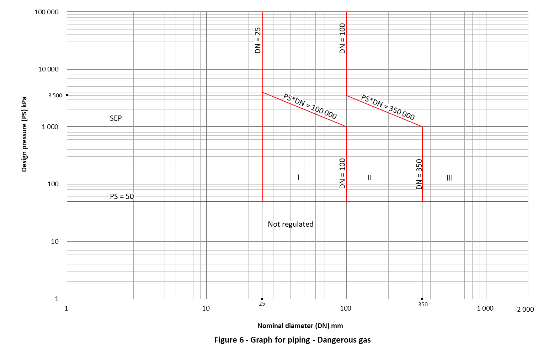

Graph for piping - Non-dangerous gas
Figure 7
Defining Equations
PS = 50 |  |  | PS*DN = 500 000
X | Y |  | X | Y
0,1 | 50 |  | 250 | 2 000
20 000 | 50 |  | 10 000 | 50
DN = 32(RED) |  |  | PS*DN = 350 000
X | Y |  | X | Y
32 | 3 125 |  | 100 | 3 500
32 | 200 000 |  | 7 000 | 50
DN = 100 |  |  | PS*DN = 100 000
X | Y |  | X | Y
100 | 200 000 |  | 32 | 3 125
100 | 3 500 |  | 2 000 | 50
DN = 250(RED)
X | Y
250 | 2 000
250 | 200 000

Axis Values
Y- Axis |  |  | X-Axis
X | Y |  | X | Y
1 | 1 |  | 1 | 1
1 | 10 |  | 10 | 1
1 | 100 |  | 100 | 1
1 | 1 000 |  | 1 000 | 1
1 | 10 000 |  | 10 000 | 1
1 | 100 000 |  | 20 000 | 1
1 | 200 000

Additional Minor gridlines
DN = 32(GREY) |  |  | PS = 3125
X | Y |  | X | Y
32 | 1 |  | 1 | 3 125
32 | 200 000 |  | 20 000 | 3 125
DN = 250(GREY) |  |  | PS = 3500
X | Y |  | X | Y
250 | 1 |  | 1 | 3 500
250 | 200 000 |  | 20 000 | 3 500

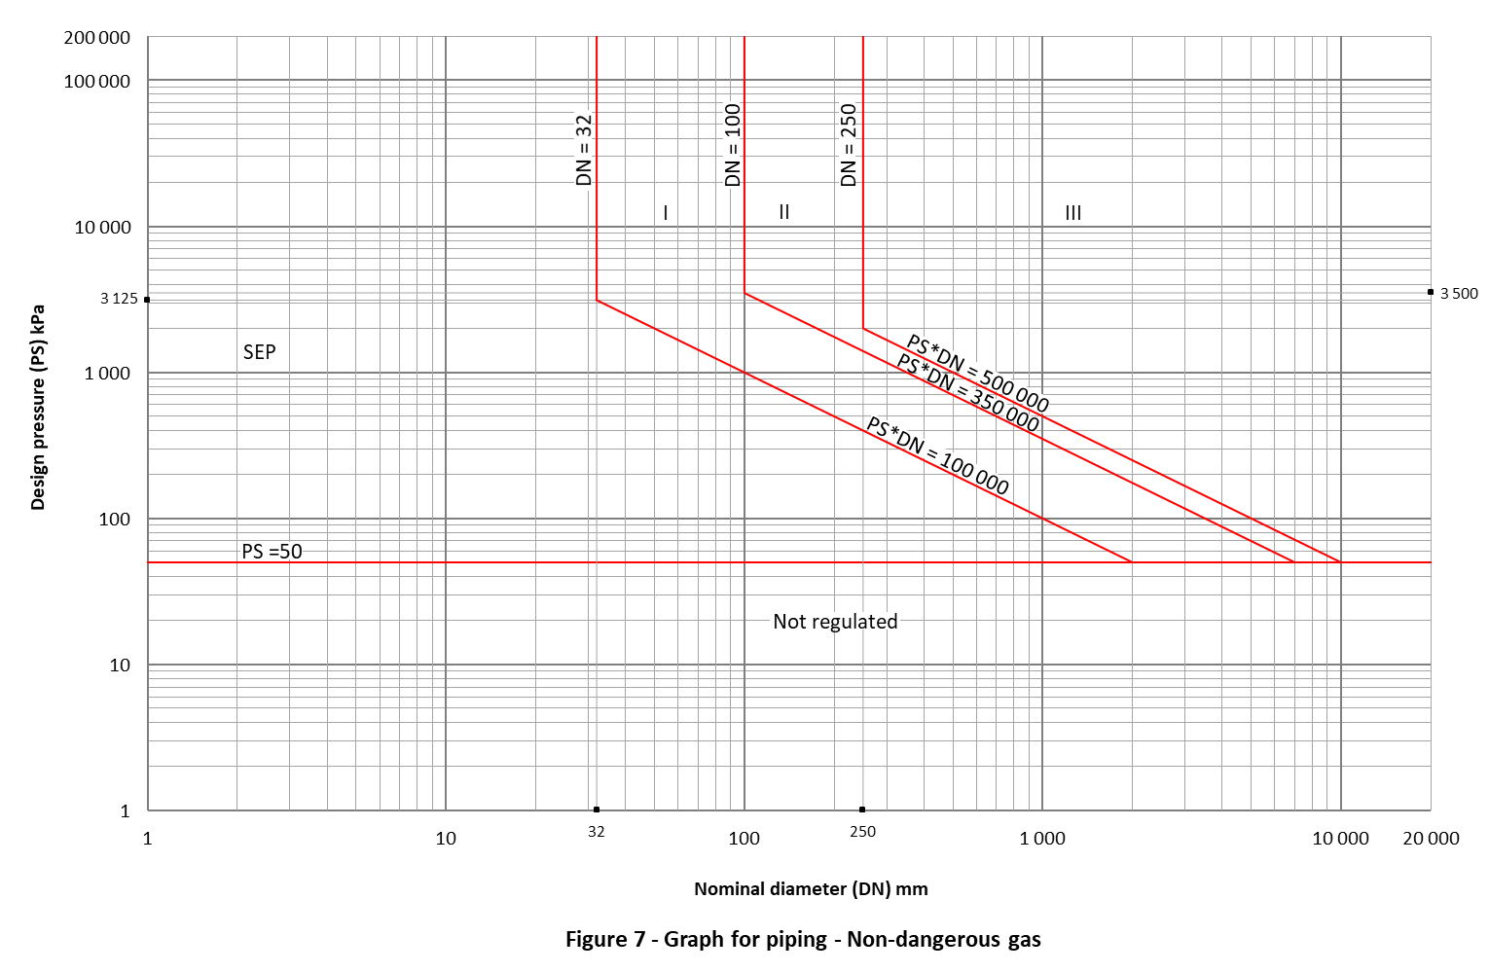

Graph for piping - Dangerous liquids
Figure 8
Defining Equations
PS = 50 000 |  |  | PS* DN = 200 000
X | Y |  | X | Y
25 | 50 000 |  | 25 | 8 000
10 000 | 50 000 |  | 2 000 | 100
PS = 1 000 |  |  | PS = 50
X | Y |  | X | Y
200 | 1 000 |  | 10 000 | 50
10 000 | 1 000 |  | 0,1 | 50
PS = 100 |  |  | DN = 25
X | Y |  | X | Y
2 000 | 100 |  | 25 | 8 000
10 000 | 100 |  | 25 | 200 000

Axis Values
Y-Axis |  |  | X-Axis
X | Y |  | X | Y
1 | 1 |  | 1 | 1
1 | 10 |  | 10 | 1
1 | 100 |  | 100 | 1
1 | 1 000 |  | 1 000 | 1
1 | 10 000 |  | 10 000 | 1
1 | 100 000
1 | 200 000

Additional Minor gridlines
DN = 25(GREY)
X | Y
25 | 1
25 | 8 000

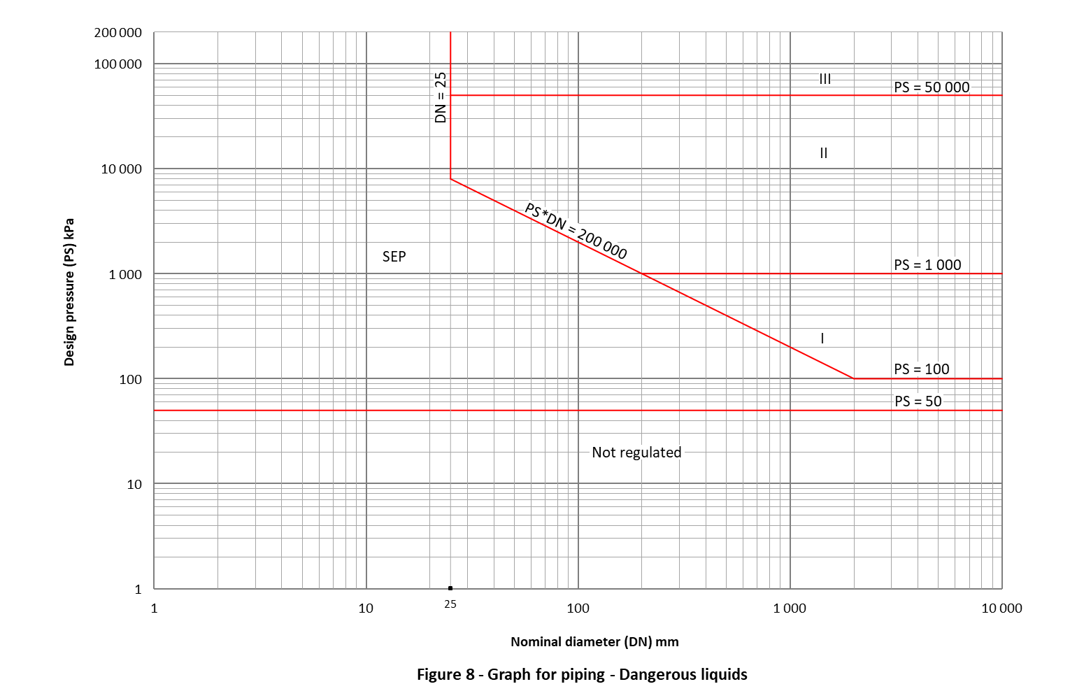

Graph for piping - Non-dangerous liquids
Graph 9
Defining Equations
PS = 50 |  |  | PS*DN = 500 000
X | Y |  | X | Y
1 | 50 |  | 200 | 2 500
10 000 | 50 |  | 500 | 1 000
PS = 1 000 |  |  | DN = 200
X | Y |  | X | Y
500 | 1 000 |  | 200 | 2 500
10 000 | 1 000 |  | 200 | 200 000
PS = 50 000
X | Y
200 | 50 000
10 000 | 50 000

Axis Values
Y- Axis |  |  | X- Axis
X | Y |  | X | Y
1 | 1 |  | 1 | 1
1 | 10 |  | 10 | 1
1 | 100 |  | 100 | 1
1 | 1 000 |  | 1 000 | 1
1 | 10 000 |  | 10 000 | 1
1 | 100 000
1 | 200 000

Additional Minor gridlines
PS = 2 500
X | Y
1 | 2 500
10 000 | 2 500

